Qualifications
Responsabilities
- Solid understanding of ESD, Latch-up, STI, WPE, electro-migration, IR drop, cross-coupling capacitance, DFM, and Antenna effect
- Responsibility for tape out process, data documentation and data archiving

Roles & Responsibilities
Responsible for the planning, organising and designing of semiconductor physical IC layout in advanced CMOS, BICMOS & BCD processes. Perform IC layout verification, and provide a well proven quality layout design within the schedule time.

Requirements:Mtechs with 4-6 years of experience as an IC Layout Designer with strong analog / mixed signal layout skills.
Strong Analog Layout design skills and capable of solving device matching, electro-migration, power distribution, latch-up, ESD etc.
MENTOR GRAPHICS TOOLS PREFERRED

The Role:
- Translation of schematic designs into mask layouts.
- Floor-planning in Analog cell/block to chip-level layout with good matching.
- Verifications of layout to ensure in compliance with technology design rules and design requirements.
- Package bonding and assembly checks.
- Proper documentation and checks for all tape-outs.
Profile
- Degree or Diploma in Electronic Engineering with a specialization in Microelectronics
- Strong layout skills in understanding of critical matching, electro-migration and latch-up
- Familiar with Linux, Cadence Virtuoso XL, Mentor Graphics Calibre tools and environment
- Strong adaptation to new design flow, new software tool
- Excellent interpersonal and communication skills

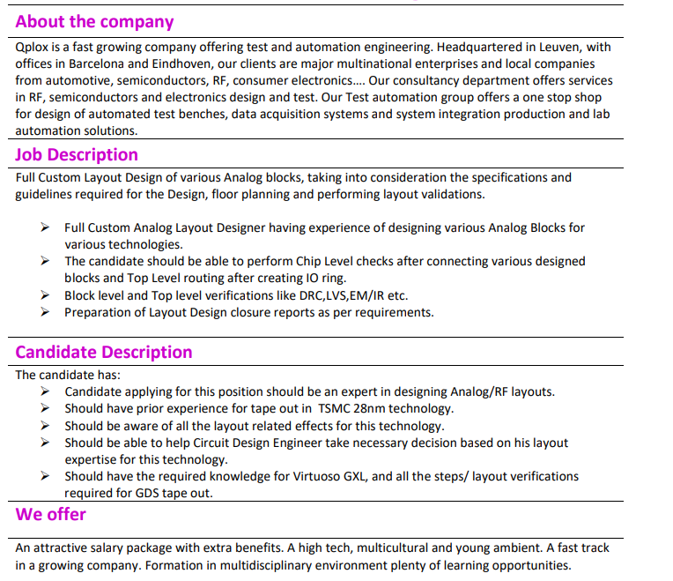
layout guidelines
- Knowledge of Integrated Circuit, device physics and advanced process technologies is an advantage
20 years of experience in analog mixed-signal / layout development (module level and top IC level)
Top layout development of ICs for automotive products
Mobile Audio team
Power management
wireless applications
Technology nodes: CMOS/BiCMOS 0.7um to 0.35um, 0.09um
Coordination of contractors based in USA, Ireland, France, India, Morroco, Serbia.
QFN, WCSP Flip Chip
Redistribution layers (RDLs)

copper pillar bump

https://careers.amd.com/careers-home/jobs/25019?lang=en-us
https://www.chipright.com/job/analog-layout-engineer-with-28nm-experience/

- Excellent problem-solving skills
- Ability to work independently as well as within a dynamic team environment
- Strong multi-tasking ability
- Strong written and verbal communication skills

- Proficiency in the use of advanced schematic capture and layout tools (e.g. Cadence Virtuoso)
- Understanding of fundamental IC design concepts, including an appreciation of device models, layout and non-idealities (e.g. parasitics) affecting performance

- Able to do feasibility studies, floorplan with many high-speed signal constraints, power plan

- Experience of critical analog layout design of blocks such as Temperature sensor, PLL, ADC, DAC, Bandgap, Ref Generators, Current Mirrors, Comparator, Differential Amplifier, etc.

- Floor planning from sub-block to chip top level
- Very good understanding of matching techniques

- Experience in manual full-custom analog layout of IC in CMOS/Bi-CMOS process

An Analog Layout Engineer is responsible for designing and optimising the layout of analog circuits and systems. They work closely with other engineers, including Analog Design, Digital Design, and Verification Engineers, to ensure that the structure meets the specified requirements and standards.
The job roles of an Analog Layout Engineer can vary depending on the specific industry and company they work for, but generally, their duties include:
- Developing and implementing layout methodologies and processes for analog circuits and systems
- Collaborating with Analog and Digital Design Engineers to ensure that the layout is optimised for area and manufacturability while meeting the specified electrical requirements
- Designing and optimising the physical layout of analog circuits and systems, including floor planning, power routing, and signal routing
- Conducting layout verification and analysis to ensure that the design meets the specified requirements and standards
- Developing and reviewing layout documentation, including GDSII files, design rule checks, and layout-versus-schematic (LVS) reports
- Providing guidance and support to other engineers to ensure that the layout is optimised for area, performance, and manufacturability
Some of the skills required for an Analog Layout Engineer include:
- Strong understanding of analog circuit and system design methodologies, processes, and standards
- Proficiency in layout tools such as Virtuoso, Calibre, and Assura
- Experience in designing and optimising the physical layout of analog circuits and systems, including floor planning, power routing, and signal routing
- Familiarity with semiconductor manufacturing processes and their impact on layout design
Overall, an Analog Layout Engineer is critical in ensuring that analog circuits and systems are designed and developed to meet the specified requirements and standards while adhering to safety and regulatory standards.

Job Description:
- Good understanding of basic VLSI concepts: CMOS, IC Fabrication, FINFET, RC Network etc.
- Expert in different Layout approaches associated with AMS/Digital/IO etc. starting from floorplan to closure with knowledge of basic circuits, matching constraints, design-driven constraints expected.
- Hands on experience in AMS layout (For example: PLL, RX, TX, Data converters, Regulator etc.) and in Custom Standard cells and logic design cells
- Experience in lower nodes including FINFET is preferred.
- Familiar and hands on experience on reliability issues such as EM/IR, ESD, LUP etc.
- Good Understanding of layout effects with related constraints in speed, parasitic, area, power and other second order effects.
- Strong debugging and problem-solving skills in resolving layout design challenges and physical verification issues.
- Self-motivated team player with good communication skill to adapt dynamic environment are essential.
- Experience in scripting (tcl, PERL etc.) and automation is a plus.
- Flexible to work in client location and ODC.
- Proficient in industry standard layout and verification tools in Linux environment.
Required Qualification:
- Bachelor’s degree in Electronics & Communication/Electrical & Electronics. Master’s degree in VLSI is preferred.
- Experience 3- 5 years of relevant experience
- Proven ability to identify, assess and solve problems
- Analytical with good interpersonal skills
- Good Communication
- Excellent team player

Responsibilities:
- Responsible for layout design of a complex high-speed, low-noise mixed-signal IP in 16nm CMOS process
- Hands-on block-level layout design and verification work, top-level IP floor-planning and integration, IC sign-off and tape-out
- Work closely with analogue design team on IP floor-planning, trial layout design and parasitic extraction of critical structures. Propose circuit design changes
- Co-ordinate layout design activities across multiple sites. Delegate block-level layout work when feasible
- Collaborate with CAD, process technology, package design and digital back-end teams
- Document own work and participate in design reviews
- Provide guidance to junior team members
Requirements:
- Experience in design of high-speed or RFlayoutinadvancedCMOS processes.
    - 16nm FinFET experience an advantage.
    - High-speed ADC layout design experience an advantage.
- Good understanding of high-speed and low-noise layout design techniques and requirements.
- Experience in top-level integration and tape-outs.
- Knowledge of semiconductor device physics and process technology.
- Communicating effectively with circuit and layout designers.
- Ability to work effectively and efficiently in a team environment
- Strong organisational and planning skills.
- Excellent multi-tasking and prioritization skills.
- Degree educated highly desirable.
Project People is acting as an Employment Business in relation to this vacancy.

Familiarity with automotive development processes is a plus.

Qualifications
- BS in EE or CE with 3+ years’ experience
- US citizenship or permanent residency
Responsibilities
- Schematic-to-GDSII implementation of analog and mixed-signal CMOS designs
at the block, core, and top levels using Cadence layout tools
- Floor-planning and layout hierarchy partitioning
- DRC, LVS, and ERC verification
- Interface with analog/mixed signal design team
Technical Skills
- Competence with layout in advanced CMOS IC processes, including FinFET
- RF/Analog layout techniques such as matching, shielding, common centroid
- Experience with Cadence or Siemens/Mentor layout tools and Calibre DRC, LVS
Preferred Experience
- Perl or Bash programming
- Previous work with DRC and LVS rule decks
- Advanced CMOS layout
Personal Skills
- Strong work ethic
- Organized, creative, motivated
- Strong interpersonal and communications skills
- Good command of written and verbal English
- Excellent teamworker
- Ability to learn and promote new techniques and methodologies
Job Location

- Typically requires more than 8 years of experience in analog/mixed-signal layout design of deep sub-micron CMOS circuits
- Experience implementing analog layouts to achieve tight matching, low noise, and low power consumption. Layouts may include analog blocks, resistors, capacitors, pad IOs, ESD structures, etc.
- High level of proficiency in custom and standard cell based floor-planning and hierarchical layout assembly.
- Must understand techniques for managing IR drop, RC delay, electromigration, self heating and coupling capacitance.
- Must recognize failure prone circuit and layout structures, have experience with analog and DFM best practices, and proactively work with circuit designer to identify the best approach to solving problems.
- High level proficiency in interpretation of CALIBRE DRC, ERC, LVS, etc. reports.
- Knowledge of MENTOR GRAPHICS or CADENCE layout tools.
- Scripting skills in PERL or SKILL are considered a plus, but not required.
- Excellent communication skills and able to work with cross-functional teams.

- Experience in Power Supplies and Power Management techniques.
- Experience with circuit verification and optimization, including layout verification.
- Knowledge of layout effects (ie. matching, reliability, proximity effects, spacing effects etc).
- Educated to degree level with excellent analytical, communication and documentation skills

- Personality: team player, motivated, creative, assertive, well-organized, analytic thinking
- Working Practice: proactive, highly responsible, independent

- Experience and Knowledge: several years of professional experience in ASIC design in the field of layout of analog and mixed-signal circuits; good knowledge in analog circuit design, also tool knowledge in Cadence Virtuoso (LayoutXL & Schematic Editor), Cadence Assura and Mentor Calibre; experience with Cadence PCell Designer, Cadence Voltus-Fi; Programming knowledge in Cadence SKILL would be an asset.

Working knowledge of PERC, latch-up risks and related ESD components for I/O pads is highly desired.
- Able to do feasibility studies, floorplan with many high-speed signal constraints, power plan

Power Stage
- Demonstrated strong interpersonal, analytical and problem-solving skills

Full custom floorplanning and constrains enrironnment included on Virtuoso layout flow
Floorplaner
- Works closely with engineering to provide high quality layout drawings that conform to schematics, in a timely manner

LAYOUT DESIGNER
03/2011 - 05/2016
New York, NY
- Recognize common analog structures and floorplan blocks utilizing best analog layout practices for the specified process
- Create and give presentations, write “how to” documents and training instructions for layout and engineering peers
- Designing processing systems in cooperation with customers, sales people, process consultants, designers and product specialists
- Make 3D layouts of processing systems (Factory Design Suite)
- Pricing of processing systems
- Preparing the layouts for mechanical designers (specifying equipment)
- Conscientious, organised, hard-working and able to do work according to well defined processes and directions
- Good fish processing and solutions knowledge
JUNIOR LAYOUT DESIGNER
04/2006 - 09/2010
Philadelphia, PA
- Responsible for checking layout drawings by use of LVS, DRC and other required verification checks
- Do block level, macro level and top level; floor planning, assembly and verification
- Proficient in leading top level layout and coordinating, scheduling and advising project layout resources to resolve technical problems and meet project schedules. Communicates regular status updates
- Takes on mentoring/leadership role with [subordinates] to promote high quality work of entire team
- Recommends changes to policies and methodologies and establishes procedures that affect immediate organization(s)
- Follows processes, methodologies and operational policies in selecting concepts and techniques for obtaining solutions
- Demonstrates an ability to learn new tool features with little supervision and proactively share knowledge with peers

- Experience in Block-level and chip level layout execution
- Experience in analog layout floor planning

POWER DEVICE ANALYSIS AND OPTIMIZATION improve designs for EM and IR drop

reliability

Coaching and mentoring junior design engineers
Managing Layout floor-planning, placement and routing

generation of bond diagram, package integration with specific tool
https://www.emplois-web.fr/emploi-informatique/2023-30989-senior-rf-analog-design-be-layout-engineer-m-f-m-f/
semiconductor physics

Job description
Developing analog/mixed-signal layout blocks that are integrated into multiple SoCs. The development of the blocks includes ADCs, DACs, DC/DC converters (buck/boost topologies), comparators, temperature sensors, on-chip sensing circuits, LDOs, GPIOs, etc.

Profile
Familiarity with analog matching requirements and practice of it in layouts is a must
Expertise on Cadence virtuoso custom/analog layout platform
Knowledge of layout techniques for device matching, minimize parasitic, high speed routing.
Working knowledge on various analog IP blocks: DCDC converters, LDOs, PLLs, ADC, DAC, Bandgap ref and other high speed connectivity circuits.
Good understanding of parasitic RC delay, power and signal integrity
Good understanding of layout extractions, verification methods which includes LVS, DRC and ERC checks.
Chip planning and block implementation (ability to estimate layout schedule for a given circuit, layout planning and provide early feedback to circuit design engineers)

- Deep knowledge of transistor operation and device physics as applied to analog design

- Good understanding of device physics and impact on analog circuits and techniques to improve performance.

https://jobs.apple.com/fr-fr/details/200315855/analog-design-engineer-f-m-d

Battery Charger controller, Wireless charger, PMIC ( module camera), ARM, Buck multiphase

